**JEEN Components Guide**



## **Introduction**

In this guide, we will review the various JEEN components, including Jeen Assistant Input, Jeen Tone Prompt, and Jeen Agent Input, and explain how each of them integrates into the Flow.

## **Component**

In Workflow - work is performed using components - blocks that represent different operations in the process. Each component performs one defined operation: such as loading a file, processing text, sending a question to artificial intelligence, or displaying an answer in chat. Components are dragged to the work screen, connected between them according to the desired order, and thus build a process flow, without writing code.

Each component receives input, processes it, and passes the result to the next component. This is the way a WorkFlow is built.

## **How to access JEEN components:**

In order to access JEEN components, you need to type JEEN in the search line, immediately after which the components will appear in the folder.

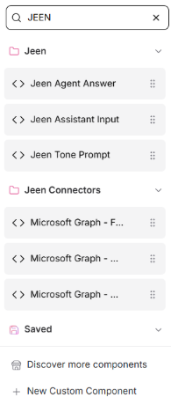

## 

## 

## 

## **JEEN Components:**

### **Components that support output from JEEN to WORKFLOW**

*For additional information beyond this guide, you can refer to the Jeen-Interactive 3-Interactive connection to WORKFLOW guide

#### **Jeen Assistant Input**

Required to start a flow of an interactive agent. When connecting workflow to Interactive agent, this component will appear immediately after the chat input, will process the information provided by the Interactive agent and organize it in a convenient structure.

* **Input** - Text in JSON format (all the information that the Interactive provides.)
* **Output** - Text/dictionary (the information that the Interactive provides organized by categories.)

תמונה שמכילה טקסט, צילום מסך, מספר, גופן

תוכן בינה מלאכותית גנרטיבית עשוי להיות שגוי.

**Jeen Tone Prompt**

When choosing to create an agent in Tone in Workflow, this component is responsible for making a connection between the final answer that returns from the Workflow to the answer that will be displayed to the Interactive agent.

It is mandatory to return the final output through the Jeen Tone Prompt component before transferring it to chat output.

* **Input** - Text (the final answer to the user).
* **Output** - Text (final answer to the user in a format that the Interactive agent supports).

תמונה שמכילה טקסט, צילום מסך, מספר, גופן

תוכן בינה מלאכותית גנרטיבית עשוי להיות שגוי.

### **Components that enable exiting from WORKFLOW to Jeen Interactive agent**

#### **Jeen Agent Input**

Component that sends a question to the JEEN Interactive agent API and receives an answer. *Must include the Agent ID

* **Input** - Text (question).
* **Output** - Python dictionary containing the answer.

